**Examples:**

Input: Maze PNG image, with red pixels in the entrance and end of the maze.

for example:

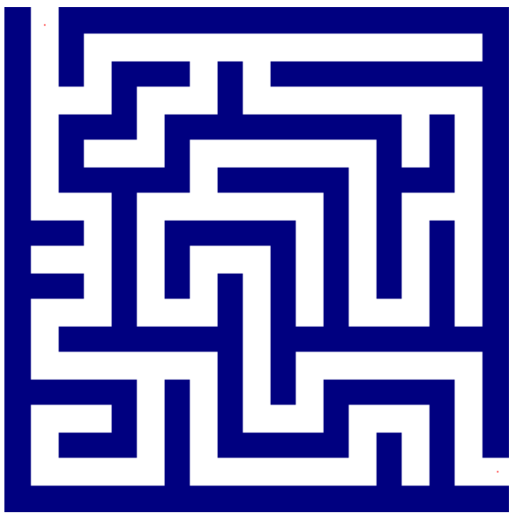

Output: The maze separated to his different components, each colored by different color. The program returns the number of components and True if the entrance and end are in the same component.

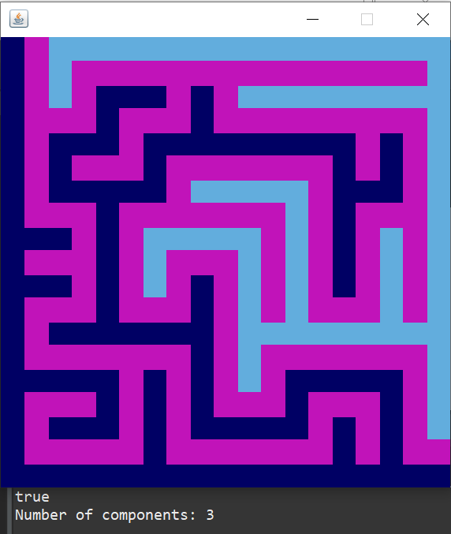

Another Example:

Input

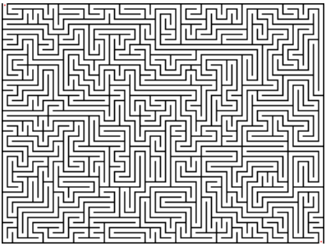

Output

